 | Mathematics Essential  Test 3, 2015  Topics - Numbers |  | 50  = %
Total Time: | 60minutes
Total Reading: | 5minutes
Total Working: | 55minutes
Weighting: | _4%_ of the year.
Equipment Allowed: | Calculator
You must include all working out to receive full marks

CALCULATOR ASSUMED

Q1. (5 Marks: 1, 2, 2)

Calculate the value of each expression when y = 5.
a) 3y² =

b) 5y - 1 =
8

c) 2(4 + 2y) =
7

Q2. (6 Marks: 2, 2 )

a) If m = 3, n = 6 and p = 2 , what is the value of 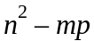.

b) If p = 10, q = 8 and r = 4 , what is the value of 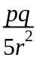?

Q3. (4 Marks: 2, 2)
a) Use the formula 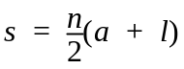 to find the value of , when 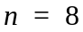. 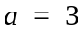and 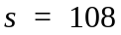

b) Use the formula 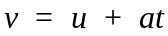 to find the value of , when 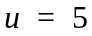. a = 4 and 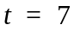.

Q4. (3 Marks)
The formula 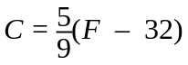 is used to convert between temperatures in degrees Celsius (C) and degrees Fahrenheit (F). Find the Fahrenheit equivalent of 35º Celsius.

Q5. (12 Marks: 2, 10)
a) Complete the missing value in the table below.
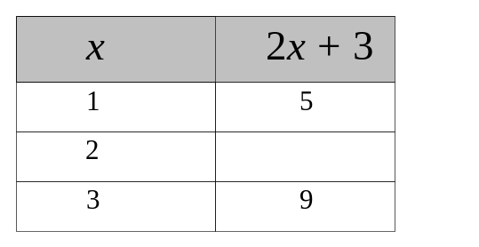

b) Complete the missing values in the table below:

x | 2 | 4 | 6 | 8 | 10
y | 1 | 3 | 5 | 7 | 12
x + y
2x + 3y
2(3x - y)
x² + y

Q6. (3 Marks )
Which equation describes the relationship between x and y?

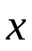 | 1 | 2 | 3
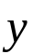 | 1 | 4 | 7

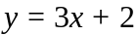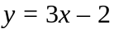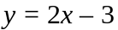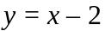

Q7. (6 Marks:1,1,1,1,1,1)
Match each equation in parts a to f with its corresponding table of values:

a) y = 2x b) y = 5 + x c) y = x²
d) x + y = 12 e) y = 6 - x f) y = x + 1
2

1.
x | 1 | 2 | 3 | 4 | 5
y | 1 | 4 | 9 | 16 | 25

2.
x | 1 | 2 | 3 | 4 | 5
y | 5 | 4 | 3 | 2 | 1

3.
x | 1 | 2 | 3 | 4 | 5
y | 11 | 10 | 9 | 8 | 7

4.
x | 1 | 2 | 3 | 4 | 5
y | 1.5 | 2 | 2.5 | 3 | 3.5

5.
x | 1 | 2 | 3 | 4 | 5
y | 2 | 4 | 6 | 8 | 10

6.
x | 1 | 2 | 3 | 4 | 5
y | 6 | 7 | 8 | 9 | 10

Q8. (6 Marks:2,2,2)
Complete each table of values:
a) y = 2x + 3
x | 1 | 2 | 3 | 4 | 5
y

b) y = 12 - 2x
x | 1 | 2 | 4 | 7 | 8
y

c) y = 3x - 5
x | 4 | 2 | 5 | 7 | 3
y

Q9. (5 Marks: 1, 2, 2)
Write the equation of the relationship between x and y in each table of values below:

a) y =
x | 1 | 2 | 3 | 4 | 5
y | 2 | 3 | 4 | 5 | 6

b) y =
x | 1 | 2 | 3 | 4 | 5
y | 5 | 10 | 15 | 20 | 25

c) y =
x | 1 | 2 | 3 | 4 | 5
y | 6 | 5 | 4 | 3 | 2

End Of Test.

